**What's new in Dynamics 365 Business Central telemetry - October 2022**

* Published on October 1, 2022
* [**Edit article**](https://www.linkedin.com/post/edit/6981894874593665024/)
* [**View stats**](https://www.linkedin.com/analytics/post-summary/urn:li:activity:6981923355809480704/)

[[](https://www.linkedin.com/in/kennie/)](https://www.linkedin.com/in/kennie/)

[Status is online](https://www.linkedin.com/in/kennie/)

**[Kennie Nybo Pontoppidan](https://www.linkedin.com/in/kennie/)**

Principal Program Manager at Microsoft

[25 articles](https://www.linkedin.com/in/kennie/recent-activity/posts/)

I visited a partner yesterday to spend a few hours discussing how they can use telemetry to be more data-driven in their project and app practices. After the meeting, I reflected on what we discussed, and I thought that this might be interesting for a broader audience.

Here are some of my key takeaways from the meeting

1. Changes to the area of telemetry happens fast and if we miss a few update on Twitter, we never learn about the new innovations.
2. The new Power BI apps are great, but we need to get them grounded in our project implementations so that it is not only our support people that use them.
3. We need to automate the setup of telemetry and deployment of Power BI apps.
4. We can see tons of benefits of the information in the apps, but we also want to be proactive on these events.
5. We struggle on how to get from "tools are available and look cool" to "how do we use them to add value to customers."

**Before we get started with the takeaways**

Here are the links that I always share after a telemetry session with a partner

* Appsource install link for the (free and open source) Power BI app on Business Central environment telemetry: [**aka.ms/bctelemetryreport**](https://aka.ms/bctelemetryreport)
* Appsource install link for the (free and open source) Power BI app (in public preview) on Business Central app telemetry: [**aka.ms/bctelemetry-isv-app**](https://aka.ms/bctelemetry-isv-app)
* Telemetry cost docs: [**https://learn.microsoft.com/en-us/dynamics365/business-central/dev-itpro/administration/telemetry-overview#ingest**](https://learn.microsoft.com/en-us/dynamics365/business-central/dev-itpro/administration/telemetry-overview#ingest)
* The new way (public preview) you can control telemetry cost: [**https://github.com/microsoft/BCTech/blob/master/samples/AppInsights/FAQ.md#how-can-i-control-cost**](https://github.com/microsoft/BCTech/blob/master/samples/AppInsights/FAQ.md#how-can-i-control-cost)
* Docs on alerting: [**https://learn.microsoft.com/en-us/dynamics365/business-central/dev-itpro/administration/telemetry-overview#setting-up-alerts-on-telemetry-events**](https://learn.microsoft.com/en-us/dynamics365/business-central/dev-itpro/administration/telemetry-overview#setting-up-alerts-on-telemetry-events)
* Sample Logic apps for alerting: [**https://learn.microsoft.com/en-us/dynamics365/business-central/dev-itpro/administration/telemetry-overview#example---run-an-alerting-query-every-n-days-and-send-an-email**](https://learn.microsoft.com/en-us/dynamics365/business-central/dev-itpro/administration/telemetry-overview#example---run-an-alerting-query-every-n-days-and-send-an-email)
* Alerting KQL queries: [**https://github.com/microsoft/BCTech/tree/master/samples/AppInsights/Alerts/AlertingKQLSamples**](https://github.com/microsoft/BCTech/tree/master/samples/AppInsights/Alerts/AlertingKQLSamples)
* Admin center sample alerting apps: [**https://learn.microsoft.com/en-us/dynamics365/business-central/dev-itpro/administration/tenant-admin-center-notifications#telemetry-in-application-insights**](https://learn.microsoft.com/en-us/dynamics365/business-central/dev-itpro/administration/tenant-admin-center-notifications#telemetry-in-application-insights)
* PBI app usage personas and scenarios: [**https://learn.microsoft.com/en-us/dynamics365/business-central/dev-itpro/administration/telemetry-power-bi-app#use-the-app**](https://learn.microsoft.com/en-us/dynamics365/business-central/dev-itpro/administration/telemetry-power-bi-app#use-the-app)
* Powerpoint presentation on how to be data-driven:[**https://github.com/microsoft/BCTech/tree/master/samples/AppInsights/Presentations**](https://github.com/microsoft/BCTech/tree/master/samples/AppInsights/Presentations)

And now on to the takeaways...

**Changes to the area of telemetry happens fast and if we miss a few update on Twitter, we never learn about the new innovations.**

Well, I admit that I use Twitter as a marketing vehicle for driving attention to the area of telemetry. When this partner (and maybe also you) mention Twitter and telemetry, I see that as a sign of success. The big marketing moments for the area though are the Business Central Launch Events and the conferences BCTechDays and Directions Asia/EMEA/US. I strive to make sure we have sessions there that covers telemetry and its use for Business Central partners and customers.

**See bleeding edge changes**

There are a few places where you can always see newest status on things

* Change log of when new signal is available: **[BCTech/samples/AppInsights/KQL at master · microsoft/BCTech (github.com)](https://github.com/microsoft/BCTech/tree/master/samples/AppInsights/KQL" \l "what-signal-is-available-in-which-version)**
* Change log for the Power BI app on environment telemetry: **[BCTech/changelog.txt at master · microsoft/BCTech (github.com)](https://github.com/microsoft/BCTech/blob/master/samples/AppInsights/PowerBI/Reports/AppSource/environment-app-pbix/changelog.txt)**
* Change log for the Power BI app on app telemetry: **[BCTech/changelog-isv-app.txt at master · microsoft/BCTech (github.com)](https://github.com/microsoft/BCTech/blob/master/samples/AppInsights/PowerBI/Reports/AppSource/isv-app-pbix/changelog-isv-app.txt)**

**What did we do on docs**

Recently, we made these big changes to docs for telemetry (you should check it out! great content):

* How to control cost of telemetry: [**https://learn.microsoft.com/en-us/dynamics365/business-central/dev-itpro/administration/telemetry-overview#ingest**](https://learn.microsoft.com/en-us/dynamics365/business-central/dev-itpro/administration/telemetry-overview#ingest)
* How to setup, configure, share, and use the Power BI app on environment telemetry: **[Analyze Telemetry with Power BI - Business Central | Microsoft Learn](https://learn.microsoft.com/en-us/dynamics365/business-central/dev-itpro/administration/telemetry-power-bi-app)**
* How to setup alerts on telemetry: [**https://learn.microsoft.com/en-us/dynamics365/business-central/dev-itpro/administration/telemetry-overview#setting-up-alerts-on-telemetry-events**](https://learn.microsoft.com/en-us/dynamics365/business-central/dev-itpro/administration/telemetry-overview#setting-up-alerts-on-telemetry-events)

**Latest videos**

Whenever I find videos about telemetry, I add links to the BC tech page [**https://github.com/microsoft/BCTech/blob/master/samples/AppInsights/VIDEOS.md**](https://github.com/microsoft/BCTech/blob/master/samples/AppInsights/VIDEOS.md)

The newest additions are

* BCTechdays 2022 session *Telemetry for Business Central from basics to advanced usage* (95 min) by Krzysztof Bialowas and Kennie Pontoppidan [**https://github.com/microsoft/BCTech/blob/master/samples/AppInsights/VIDEOS.md#2022-09-16-bc-techdays-2022---telemetry-for-business-central-from-basics-to-advanced-usage-95-min-by-krzysztof-bialowas-and-kennie-pontoppidan**](https://github.com/microsoft/BCTech/blob/master/samples/AppInsights/VIDEOS.md#2022-09-16-bc-techdays-2022---telemetry-for-business-central-from-basics-to-advanced-usage-95-min-by-krzysztof-bialowas-and-kennie-pontoppidan)
* *Telemetría en Business Central: Como Empezar con la aplicación de Power BI* (10 min in Spanish) by Javier Armesto [**https://github.com/microsoft/BCTech/blob/master/samples/AppInsights/VIDEOS.md#2022-07-29-telemetr%C3%ADa-en-business-central-como-empezar-con-la-aplicaci%C3%B3n-de-power-bi-10-min-in-spanish-by-javier-armesto**](https://github.com/microsoft/BCTech/blob/master/samples/AppInsights/VIDEOS.md#2022-07-29-telemetr%C3%ADa-en-business-central-como-empezar-con-la-aplicaci%C3%B3n-de-power-bi-10-min-in-spanish-by-javier-armesto)
* Areopa webinar 2022: How to get data driven in your partner practice with telemetry (60 min) by Kennie Pontoppidan [**https://github.com/microsoft/BCTech/blob/master/samples/AppInsights/VIDEOS.md#2022-07-10-areopa-webinar-how-to-get-data-driven-in-your-partner-practice-with-telemetry-60-min**](https://github.com/microsoft/BCTech/blob/master/samples/AppInsights/VIDEOS.md#2022-07-10-areopa-webinar-how-to-get-data-driven-in-your-partner-practice-with-telemetry-60-min)

**Upcoming online and physical presentations**

Then we have upcoming online and physical presentations on the topic

* 2022-10-04: Office hours call on 'Get data-driven with Telemetry'. We will talk about how to use telemetry to change your business processes and demo the new Power BI app. There will be open for Q&A during the session. Register here: [**https://aka.ms/BCOfficeHours**](https://aka.ms/BCOfficeHours)
* 2022-10-10: Business Central Launch Event. A free virtual event for everyone from reselling partners and consultants to ISVs and customers. We'll be talking about what's new in [**#MSDyn365BC**](https://www.linkedin.com/feed/hashtag/msdyn365bc), including a full session on using telemetry to be data driven as a partner. Register here: [**https://aka.ms/BCLE**](https://aka.ms/BCLE)
* 2022-11-09: Directions EMEA 2022 in Hamburg (paid event). There will be several sessions and workshops on telemetry here. I will do a session on how to get data-driven using the new Power BI apps, we will do a 2-hour walk-in workshop where experts from Microsoft and the community will help you with whatever you struggle with on the topic, and I have seen several sessions around telemetry given by community speakers. Register here: [**https://directions4partners.com/events/directions-emea-2022**](https://directions4partners.com/events/directions-emea-2022)
* 2022-11-21: Microsoft MVP Krzysztof Bialowas is kicking off his new online course *Telemetry in a Day* (paid). Register here: [**https://www.mynavblog.com/telemetry-in-a-day-online**](https://www.mynavblog.com/telemetry-in-a-day-online) (no, I do not get any kickback for advertising it here).

**The new Power BI apps are great, but we need to get them grounded in our project implementations so that it is not only our support people that use them.**

This is IMO a matter of maturity in your use of the data. In most partner organizations, telemetry usage starts with people working in support and troubleshooting. This is great because using data drives down the Time-To-Mitigate (TTM) for customer issues. Just think of how much time is spent getting information on which version the customer uses to kick off a support case: likely (many) emails going back and forth, each time adding new people to the email thread. Compare that with a situation where the support engineer can just look it up without the need to ask ("I can see that you are on version x.y. I can also see that a new version of app ABC was installed on Friday. Maybe this is related to the issue."

To help you get telemetry used to support the sales and project implementation parts of your organization, we added examples of scenarios for these personas where the telemetry and the Power BI apps might be of help. Read more here on docs: [**https://learn.microsoft.com/en-us/dynamics365/business-central/dev-itpro/administration/telemetry-power-bi-app#use-the-app**](https://learn.microsoft.com/en-us/dynamics365/business-central/dev-itpro/administration/telemetry-power-bi-app#use-the-app)

If you want more ideas on how to get telemetry used in more parts of your partner organization, take a look at the Telemetry Maturity Model presented in the Powerpoint deck *Using telemetry to improve your partner practices and processes.pptx.*The model lets you asses where you are on a scale from 1-5 and ideas for what to do to get from one stage to the next.

Download the deck here: [**Using telemetry to improve your partner practices and processes.pptx**](https://github.com/microsoft/BCTech/tree/master/samples/AppInsights/Presentations)

**We need to automate the setup of telemetry and deployment of Power BI apps**

To get telemetry and the Power BI apps in as a natural part of dealing with Business Central implementation projects, you probably need to start automating things.

The Admin Center API allows you to enable telemetry for an environment. Reading through docs, I could only see a method to do so using an instrumentation key (the deprecated way). I will follow up with the team to ensure that the right way (using a connection string) is both available in the API and documented in docs.

Read more here on docs: https://learn.microsoft.com/en-us/dynamics365/business-central/dev-itpro/administration/administration-center-api_environment_settings#put-appinsights-key

As for deploying the Power BI apps, I need to learn more about the Appsource APIs. Stay tuned. Until then, installing the Power BI apps might be a manual process for now.

**We can see tons of benefits of the information in the apps, but we also want to be proactive on these events.**

Yeah, that is only a natural next step. Once you start consuming data, you want to react on it as well (that is the *driven* part of being data-driven).

**Setting up alerts on telemetry events**

If something happens in your environment or app that you need to take action on, you might want to have a system that sends you an alert. Azure Application Insights makes it easy to define such alerts.

You can use the following tools to define and set up alerts on telemetry events

1. Azure Application Insights Alerts,
2. Azure Logic Apps, or
3. Power Automate

All three approaches need a Kusto (KQL) query to define the alerting condition.

**Alerting condition queries**

When defining an alert based on telemetry, you need to define two things:

1. A Kusto (KQL) query that defines the alerting condition. It's considered good practice to add a where clause that limits the timestamp of events in the query, e.g. **| where timestamp > ago(1h)**.
2. How often you want to run the alerting query. Typically the recurrence follows the where clause in the alerting query. E.g. if the query looks back 1 hour, then you set your recurrence to 1 hour as well.

Samples of alerting queries are shared by Microsoft and third parties on the [**Business Central BCTech repository on GitHub**](https://github.com/microsoft/BCTech/tree/master/samples/AppInsights/Alerts). You can also share your alerting queries with the community on GitHub.

**Example apps for alerting**

We added a few sample apps on docs to make it super easy for you to get started with this:

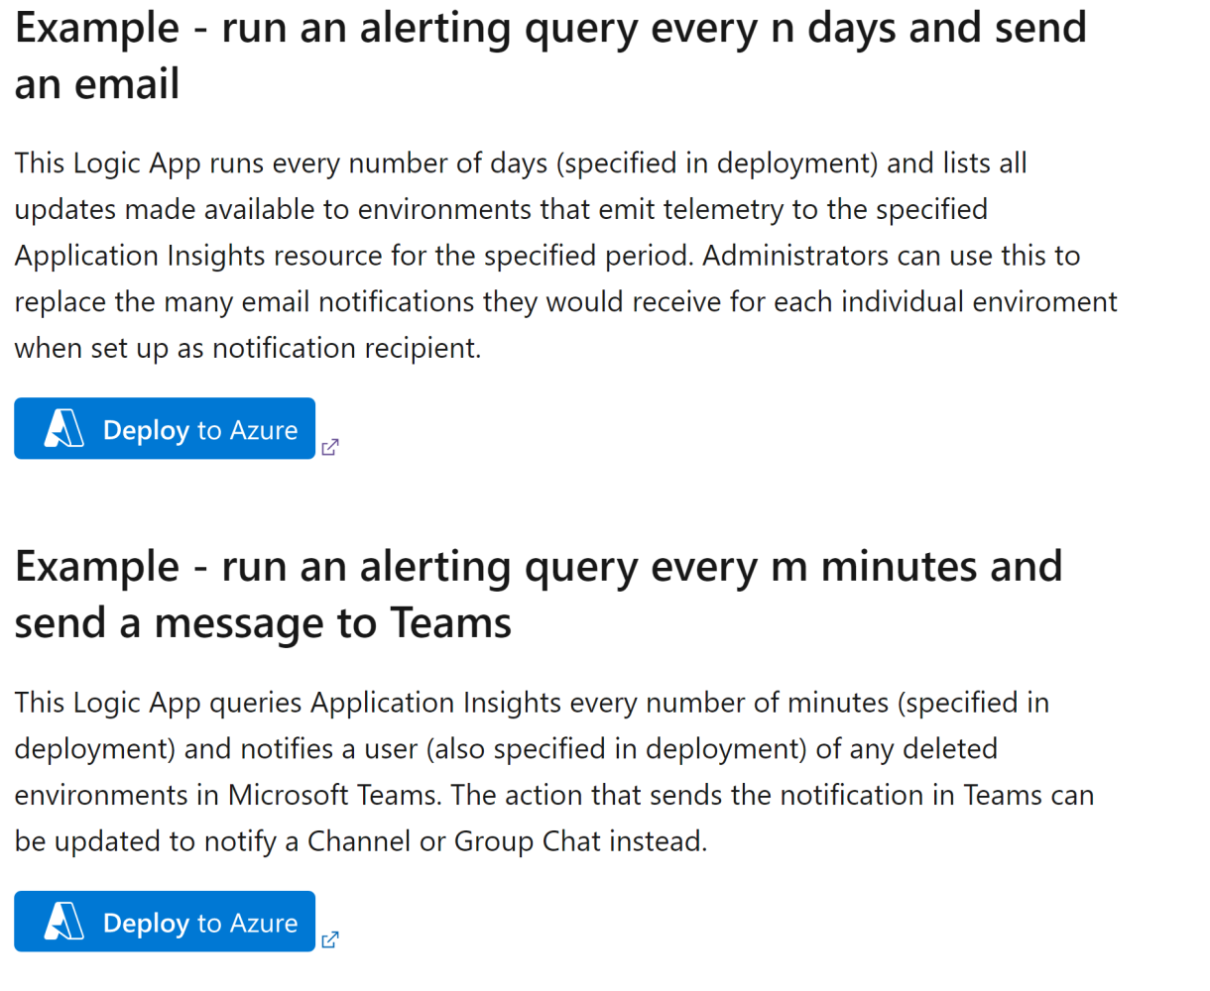

(ha ha ha, it is just a picture...). Read more about how to setup alerts here on docs: [**https://learn.microsoft.com/en-us/dynamics365/business-central/dev-itpro/administration/telemetry-overview#setting-up-alerts-on-telemetry-events**](https://learn.microsoft.com/en-us/dynamics365/business-central/dev-itpro/administration/telemetry-overview#setting-up-alerts-on-telemetry-events)

(here, you will also find the actual buttons that deploy sample apps with a click.)

**We struggle on how to get from "tools are available and look cool" to "how do we use them to add value to customers."**

It is ok, we struggle too in Microsoft to do this. I suggest you do this

1. enable telemetry for all production environments. Make sure that someone looks at the docs for cost control when setting up Application Insights so that you do not get any nasty surprises. I have heard about partners who have enabled telemetry on 150 environments and pay 100 USD per month for this (IMO that is not expensive.)
2. Pick a few implementation projects and install and configure the Power BI app on their telemetry. Share the app with project managers and consultants and show them a few insights about this customer. Go through the *Project Manager* scenarios described here in docs: [**https://learn.microsoft.com/en-us/dynamics365/business-central/dev-itpro/administration/telemetry-power-bi-app#use-the-app**](https://learn.microsoft.com/en-us/dynamics365/business-central/dev-itpro/administration/telemetry-power-bi-app#use-the-app)
3. Pick a few existing customers where sales representatives are planning to come visit on follow ups. Install and configure the Power BI app on the telemetry for these customers. Share the app with the sales team and go through the *Account Manager* scenarios described here in docs: [**https://learn.microsoft.com/en-us/dynamics365/business-central/dev-itpro/administration/telemetry-power-bi-app#use-the-app**](https://learn.microsoft.com/en-us/dynamics365/business-central/dev-itpro/administration/telemetry-power-bi-app#use-the-app)
4. Now you are already halfway there. Now look at the Telemetry Maturity Model (described above) and take it to the next level(s).

Thats it folk! Next post could be on how ISVs can use the new (free and open source) Power BI app (currently in public preview) on their telemetry to also be data-driven on their organization. Stay tuned.